**CORPORATE FINANCE AND FINANCIAL ANALYSIS**

**GROUP COURSEWORK**

# Executive Summary

This assignment explores corporate finance in the context of pandemics, with a focus on dividend theories in ideal markets. The financial assessments of AstraZeneca (AZN) and GlaxoSmithKline (GSK) for the years 2020–2022 are examined, with an emphasis on investment opportunities, taxation, sustainability, the impact of dividends, and clientele consequences. GSK presents a heterogeneous ownership structure, whereas AZN presents a stable one. Complex tax laws have an impact on earnings and shareholder value. Both companies show that they are committed to sustainability. Furthermore, adequate suggestions are also included in the paper.

**Table of Contents**

Executive Summary 2

Introduction 4

Section A 4

Critical evaluation of the irrelevance argument 4

Section B 4

a) Clientele effects 4

b) Taxation 5

c) Dividends as information conveyors 5

(i) Significance of dividends to investors 5

(ii) Share performance of the selected company 6

d) Sustainability 6

e) Investment opportunities 7

f) Liquidity issues and other financing obligations 8

Conclusion and recommendations 9

Reference List 10

Appendices 12

Financial ratios calculation 12

# Introduction

The term "corporate finance and financial evaluation" evolves from accessing the firm's performance, strategies, and financial decisions for effective planning and decision-making. The assignment explores the theory of dividend irrelevance in perfect capital markets, with a particular focus on pandemic situations. Besides, this report focuses on empirically examining the financial performance of "AstraZeneca (AZN) Plc" and "GlaxoSmithKline (GSK) Plc." Financial assessments of these two firms are presented for the last 3 years from 2020 to 2022.

# Section A

## Critical evaluation of the irrelevance argument

A key component of a business's financial plan evolves the dividends payment to shareholders. It has long been believed that companies can change their dividend policies to affect their value. Moreover, Miller and Modigliani's dividend irrelevance argument refutes this idea, claiming that a firm's worth stays constant in a frictionless market regardless of its pay-out policy (Henry, Lucky & Muhammed 2023). Shareholders can change their income preferences by selling equity or reinvesting extra dividends relative to lower-than-desired dividend payouts. This suggests that dividend policy becomes irrelevant to the firm's valuation in an ideal capital market.

As understood by Brusov & Filatova (2022), research supports the dividend irrelevance argument by showing that enterprises can modify current dividends without affecting their total value, while investment decisions are influenced by dividend policy. In frictionless markets, shareholders can use reinvestment or divestment techniques to manage the amount of income they wish to receive, making dividend policy inconsequential to the firm's worth.

# Section B

## a) Clientele effects

A change in shareholder expectations may be seen in GSK Plc's diversified ownership structure, which includes significant non-controlling interests in 2022 worth £ (502) million as opposed to the prior year of £ 6,287 million. The drop in retained earnings from £ 7,944 million in 2021 to £ 4,363 million in 2022 could indicate a shift in the distribution strategy of the company, thereby affecting shareholders' dividend expectations (GSK Plc | Annual report, 2022).

In comparison, AstraZeneca Plc exhibits stability in its ownership structure and maintains a high level of retained earnings amounting to $ 1,710 million in 2021 (AstraZeneca Plc | Annual report, 2022). This points to a more cautious dividend policy that will appeal to long-term growth investors. A preference for reinvestment over large dividend pay-outs is implied by the company's stable capital structure and the comparatively limited non-controlling interests. Hence, closely held corporations like AstraZeneca are willing to accept smaller rewards with shareholders asking for capital appreciation.

## b) Taxation

The taxation initiatives of ASZ and GSK pose crucial ramifications for shareholders' wealth, profit, and capital structure. One important factor that directly affects net income and shareholder wealth is corporate tax. For such, GSK incurred £ 67 million in corporate tax expenses in 2020, which had an effect on their profit after tax. Besides, AstraZeneca had to pay $ 772 million in taxes in the same year (AstraZeneca Plc | Annual report, 2022). Both firms' capital structures include a corporate tax shield that protects profits from high taxes and increases shareholder wealth. Individual income tax on dividends received is another issue that shareholders face, which has an impact on their total returns. The differing tax valuations for GSK and AstraZeneca from 2020 to 2022 demonstrate how tax dynamics affect profits and subsequently the wealth of shareholders. This underscores the complex interplay between corporation tax, income tax, and capital gain tax in determining the firm’s financial results.

## c) Dividends as information conveyors

### (i) Significance of dividends to investors

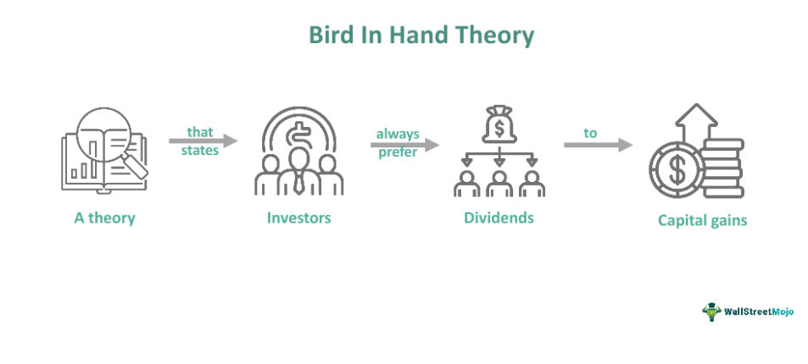

**Figure 1: The Bird-in-Hand Theory**

(Source: Banu, 2022)

For investors, dividends emerge as a pillar that sums up a company's financial stability and its dedication to its potential owners. According to the Bird-in-Hand theory, investors value present dividends more than uncertain capital gains since they are a consistent source of income (Banu, 2022). The Bird-in-Hand theory is supported by GSK's steady dividend payments as observed in 2020 and 2021 and provides investors with steady revenue streams. On the other hand, the drop in dividends in November 2022 raises concerns as it can signal changes in the company's strategic or financial orientation (GSK plc (GSK) stock historical prices & data, 2023).

### (ii) Share performance of the selected company

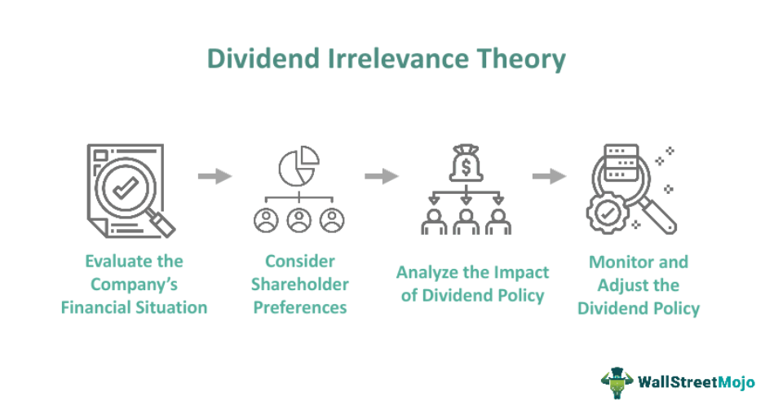

**Figure 2: Dividend Irrelevance Theory**

(Source: Avcı & Sarıgül, 2023)

The information content theory indicates that share prices react to announcements of dividends by incorporating fresh insights into a company's prospects for the future. This tendency is evident relative to the share prices of GSK, with an upswing following the 0.391 dividend in August 2022. The same is also true for AstraZeneca, whose share prices are probably impacted by the 0.465 dividend announcement in August 2022 (AZN plc (AZN) stock historical prices & data, 2023). Moreover, the dividend-relevance theory contends that stock prices should not be impacted by dividend policy in ideal markets (Avcı & Sarıgül, 2023).

## d) Sustainability

Both AZN and GSK have reflected an increasing sustainability awareness, especially in association with the United Nations Sustainable Development Goals (SDGs). Both businesses have demonstrated a dedication to numerous SDGs such as responsible consumption and production (SDG 12), good health and well-being (SDG 3), and climate action (SDG 13).

GSK has improved access to healthcare by guaranteeing that medications are affordable and readily available everywhere in the world. Furthermore, certain detractors ensure that irrespective of their core implications, pricing strategies might result in challenges in certain sections (Weston & Nnadi, 2023). GSK has employed practices to deal with climate change yet can add more to enable aggressive objectives for reducing carbon emissions.

Besides, AZN has focused on healthcare accessible to people, especially in low-earning countries. However, issues with its pricing policies and patents have surfaced, which may restrict accessibility. By establishing challenging carbon neutrality targets and making investments in renewable energy, they have taken climate action (Sami, 2022). Moreover, critics doubt the breadth of their dedication, notably in reporting openness and the integration of corporate strategies with sustainability goals. Both corporations have achieved significant progress in sustainability. Nonetheless, some critics highlight the need for more open reporting, stricter compliance with ethical pricing, and more aggressive climate action goals to align with the ambitious UN SDGs and effect positive change.

## e) Investment opportunities

**Figure 3: Debt-to-equity ratio of GSK and AZN over three years**

(Source: Spreadsheet)

The debt-to-equity ratios of both companies reflect increases over the three periods. The ratio of GSK indicates an increase, whereas that emerges as an improvement of AZN's ratio. This ensures that AZN has better financial performance compared to GSK. Besides, AZN's share price increased by 12% in the past period, while GSK Plc's share price decreased by the rate of 15% (GSK Plc | Annual report, 2020). This implies that investors are feeling more positive about the possibilities of growth for AZN Plc’s business in the future. Moreover, GSK Plc recently purchased Innovent Biologics, while AZN Plc purchased Alexion Pharmaceuticals to ensure expansion (Tulum, Andreoni & Lazonick, 2022). Additionally, neither company has announced any recent mergers or acquisitions.

## f) Liquidity issues and other financing obligations

**Figure 4: Interest coverage ratio of GSK and AZN over three years**

(Source: Spreadsheet)

**Figure 5: Current ratio of GSK and AZN over three years**

(Source: Spreadsheet)

AZN's interest coverage ratio improved between 2020 and 2022, indicating a stronger ability to use operating earnings to pay interest. Nonetheless, given that current liabilities are subject to surpass current assets in 2022, the current ratio drop suggests possible liquidity issues. This could affect the company's capacity to pay for short-term obligations and urgent funding demands. Comparatively, GSK shows a strong improvement in the current ratio and interest coverage between 2020 and 2022 (GSK Plc | Annual report, 2022). Strong short-term liquidity is shown by the current ratio improvement and the interest coverage ratio, which both point to a stable ability to pay interest. In managing financial commitments and any additional borrowings, this implication puts GSK in a better position.

Referring to their liquidity positions, both businesses should exercise caution. AZN in particular has to address a falling current ratio. In contrast, GSK looks to be in a good situation relative to its increased cash and interest coverage. Both should take into account their financing responsibilities and assess their capacity to take on new debt, taking into account the state of the market, their general financial situation, and any potential effects on creditworthiness.

# Conclusion and recommendations

GSK shows a varied ownership pattern that may affect shareholders' expectations for dividends, whereas AZN exhibits a stable ownership structure. The intricate relationship between corporate and income taxes is highlighted by how tax intricacies affect the wealth of shareholders as well as the profitability of businesses.

Furthermore, both businesses have sustainability initiatives that support the UN SDGs. Even if AZN's debt-to-equity ratio is improving and its share price is rising, there still exists liquidity issues. By comparison, GSK has enhanced liquidity and sound financial standing, which puts it in a favourable position for possible borrowings. Recommendations include AZN addressing its diminishing liquidity and both companies continuously monitoring tax dynamics and supporting sustainability initiatives. Furthermore, GSK can contemplate strategic acquisitions as a means of expanding, given its enhanced financial standing.

# Reference List

AstraZeneca Plc | Annual report (2022). AstraZeneca. Available at: <https://www.astrazeneca.com/content/dam/az/Investor_Relations/annual-report-2022/pdf/AstraZeneca_AR_2022.pdf> (Accessed: 02 December 2023).

Avcı, P., & Sarıgül, S. S. (2023, February). Evaluation between Dividend Policies and Firm Value. In International Conference on Frontiers in Academic Research (Vol. 1, pp. 412-417). <https://as-proceeding.com/index.php/icfar/article/view/140>

AZN plc (AZN) stock historical prices & data (2023). Yahoo! Finance. Available at: <https://finance.yahoo.com/quote/AZN/history?period1=1577836800&period2=1672444800&interval=1mo&filter=history&frequency=1mo&includeAdjustedClose=true> (Accessed: 02 December 2023).

Banu, S. (2022). Trajectory of the Internationalisation of Small and Medium Enterprises and Effectuation Theory. <https://www.researchgate.net/profile/Saira-Banu-2/publication/369994180_Trajectory_of_the_Internationalisation_of_Small_and_Medium_Enterprises_and_Effectuation_Theory/links/645f38a6fbaf5b27a4c2fcbd/Trajectory-of-the-Internationalisation-of-Small-and-Medium-Enterprises-and-Effectuation-Theory.pdf>

Brusov, P., & Filatova, T. (2022). Recent Development of Modigliani-Miller Theory. Strategies in Accounting and Management, 3(5), 1-2. <https://www.sunbeltsport.com/siam/pdf/SIAM.000572.pdf>

GSK plc (GSK) stock historical prices & data (2023). Yahoo! Finance. Available at: <https://finance.yahoo.com/quote/GSK/history?period1=1577836800&period2=1672444800&interval=1mo&filter=history&frequency=1mo&includeAdjustedClose=true> (Accessed: 02 December 2023).

GSK Plc | Annual report (2020). GlaxoSmithKline. Available at: <https://www.gsk.com/media/6662/annual-report-2020.pdf> (Accessed: 02 December 2023).

GSK Plc | Annual report (2022). GlaxoSmithKline. Available at: <https://www.gsk.com/media/9956/annual-report-2022.pdf> (Accessed: 02 December 2023).

Henry, K. F., Lucky, U. A., & Muhammed, A. A. (2023). Capital Structure Decisions and Dividend Policy. <https://cognizancejournal.com/vol3issue7/V3I745.pdf>

Sami, A. (2022). Corporate Social Responsibility is NOT an Option is an Investment: A Study of AstraZeneca. Asian Journal of Economics, Finance and Management, 437-444. <https://www.globalpresshub.com/index.php/AJEFM/article/view/1656>

Tulum, Ö., Andreoni, A., & Lazonick, W. (2022). From financialisation to innovation in UK big pharma: AstraZeneca and GlaxoSmithKline. Cambridge University Press. <https://www.cambridge.org/core/elements/from-financialisation-to-innovation-in-uk-big-pharma/A077D6158F0A945ED53F3F125EE0650F>

Weston, P., & Nnadi, M. (2023). Evaluation of strategic and financial variables of corporate sustainability and ESG policies on corporate finance performance. Journal of Sustainable Finance & Investment, 13(2), 1058-1074. <https://www.tandfonline.com/doi/abs/10.1080/20430795.2021.1883984>

# Appendices

## Financial ratios calculation

|  |  |  |  |  |  |  |
| --- | --- | --- | --- | --- | --- | --- |
|  | **AZN Plc** | | | **GSK Plc** | | |
| **Particulars** | **2022 (£ m)** | **2021 (£ m)** | **2020 (£ m)** | **2022 (£ m)** | **2021 (£ m)** | **2020 (£ m)** |
| Debt | 59425 | 66076 | 51091 | 50050 | 57761 | 59623 |
| (/): Equity | 37058 | 39287 | 15638 | 10096 | 21342 | 20808 |
| **Debt to equity ratio** | **1.60** | **1.68** | **3.27** | **4.96** | **2.71** | **2.87** |
|  |  |  |  |  |  |  |
|  | **AZN Plc** | | | **GSK Plc** | | |
| **Particulars** | **2022 (£ m)** | **2021 (£ m)** | **2020 (£ m)** | **2022 (£ m)** | **2021 (£ m)** | **2020 (£ m)** |
| EBIT | 3757 | 1056 | 5162 | 6433 | 4357 | 5979 |
| (/): Interest Expenses | 1346 | 1300 | 1306 | 879 | 769 | 874 |
| **Interest coverage ratio** | **2.79** | **0.81** | **3.95** | **7.32** | **5.67** | **6.84** |
|  |  |  |  |  |  |  |
|  | **AZN Plc** | | | **GSK Plc** | | |
| **Particulars** | **2022 (£ m)** | **2021 (£ m)** | **2020 (£ m)** | **2022 (£ m)** | **2021 (£ m)** | **2020 (£ m)** |
| Current assets | 22593 | 26244 | 19544 | 20769 | 18674 | 20247 |
| (/): Current liabilities | 26293 | 22594 | 20307 | 22810 | 23670 | 22148 |
| **Current ratio** | **0.86** | **1.16** | **0.96** | **0.91** | **0.79** | **0.91** |